Walk to Cure Diabetes 2014
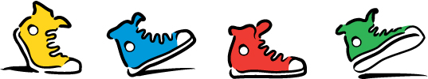

The JDRF Walk to Cure Diabetes brings people together in a healthy activity for a worthy goal. The Walk is fun for families and builds camaraderie among company employees. It provides hope, empowerment and a sense of community. Your participation shows your commitment to the large scale movement to conquer type 1 diabetes one step at a time.

Saturday, September 20, 2014 Saturday, September 27, 2014
Schenley Park, Pittsburgh University of Pittsburgh at Greensburg

Register your walk team now by going to http://walk.jdrf.org!

Our walks include families of all ages and generations and include children’s activities like face painting and bounce houses, music, food, entertainment and games and so much more.

The Walk to Cure Diabetes is a hugely successful event and it the 6th largest peer-to-peer fundraising event in the United States. Each year there are more than 200 Walks in the United States and dozens more take place internationally. More than 600,000 people participate each year. Since 1992, the JDRF Walk to Cure Diabetes has raised more than $1 billion for type 1 diabetes research! And we have reached this milestone through the donations, large and small, raised by our walkers.

We are here to help!
Family Team Partner Corporate Team & Sponsorship Partner
Lara Daly Jennifer Zgurich
ldaly@jdrf.org jzgurich@jdrf.org
412-471-1414 x5 412-471-1414 x4

